Application Decommissioning Requirements and Planning Guide
for
1660/Commercial Umbrella
Approved on mm/dd/2026

Table of Contents
Executive Summary 3
Application Overview 6
Decommissioning Approach 9
Business Requirements 10
Records Retention Requirements 11
Legal/Contractual Requirements 13
Organization Change Management (OCM) 14
Operational / Technology Review 15
Sign Off 17
Document History 18
Appendix 19

Executive Summary

Application Overview
Commercial Umbrella is an internal only legacy web application used for calculating umbrella premium. Business reference document (Coml Umbrella Calculator Job Aid.pdf) talks about using it for new business and renewals related to PCIO accounts.
It is not a policy system or the final source of what gets issued. If there was a desire to create or update a policy based off the information, it had to be manually keyed into the PCIO mainframe policy entry system. All processing within the web app is self-contained and doesn’t have direct interfaces with other systems.
The app is no longer needed with the migration to the go forward CL PolicyCenter platform.

Historic Data Requirements
Two types of data stored in the app’s COMUDB SQL Server database in the cloud.
- Fifteen tables that contain data entered by a user
- Fifteen tables that contain business rules for things like class codes, endorsements, rates, etc.
SQL Server table details are documented in this spreadsheet - Commercial Umbrella table names - details.xlsx.
Besides the app’s SQL Server database, copies of the data also resides in the Data Lake raw/ingestion layer - hive_metastore.pcds_agreement_umbrellacalc_raw.
Since the Commercial Umbrella Calculator isn’t an actual policy system, the data will be treated as quote data and any data retention requirements will be met similar to CIQ by relying on the data in the Data Lake.

Timeline for Decommissioning

Task | Date | Notes
Decide when Commercial Umbrella web app can be turned off? | 06/30/2026 | Usage has continued to fall off the past year. It was used 5 days in November 2025, 5 days in December 2025, and so far 3 days in January 2026.  Back in November 2025 did some research reaching out to a few people still using the app. They were Territory Managers working with Middle Market accounts. They talked about using for midterm quotes and also doing comparisons as accounts migrate into CL PolicyCenter. Based on this information, the decommission target was moved as there was hesitance to turn off much before the last PCIO policy expires on 5/1/2026.
Historical data archive/retention requirements agreed upon | 02/11/2026 | On 2/11/2026, confirmed with Matt Olson that the data does exist in the Data Lake raw/ingestion layer - hive_metastore.pcds_agreement_umbrellacalc_raw.  We spot checked this by finding information in the app’s SQL Server database, then Matt found the same information on the Data side.
Any OCM activities? | N/A | Per Dawn Thompson: Given current usage, it feels like a formal communication is not needed.
Fully analyze/document Commercial Umbrella system components that will be decommissioned | 01/29/2026 | Component Inventory complete
Submit DBA request to check to see if there are any unexpected ids/systems that have used the COMUDB SQL Server database recently. | XX/XX/2026 | Do this step when closer to turning off the web app. Data Warehouse area must have a nightly feed, wouldn’t expect anything else to be hitting it.
Turn off Commercial Umbrella application | XX/XX/2026 | App was supported by Chaos Monkeys development line before it was dissolved as part of the reorganization. Assume the new House Band development line will handle turning off similar to what was done for Commercial Rate Step Maintenance.
Develop and execute on any data archive/retention tasks identified | N/A | Confirmed that the same data that exists in the app’s SQL Server database also exists in the Data Lake. Any retention needs will be met by the data being in the Data Lake.
Decommission Commercial Umbrella system components | XX/XX/2026 | After the app has been turned off, work through the items identified in the Component Inventory to either delete or revoke as clean up items.
Decom complete | XX/XX/2026

Application Overview

Application Functionality
See the copy of the business job aid (Coml Umbrella Calculator Job Aid.pdf) for details how underwriting utilized the app.
In addition, found an original document (Commercial Umbrella - Induction Document 2006.doc) from contracting company that must have originally built the application for Nationwide back in the early 2000’s. Some of the wording and comments in the document don’t seem completely accurate, but does give a general overview of the app screens.
High level features:
- Policy General Information
- Underlying Coverages
- General Liability
- Auto Liability
- Garage Liability
- Employers Liability
- Employee Benefits Administration Liability
- Printer Error and Omissions Liability
- Liquor Liability
- Golf Course Directors and Officers Liability
- Pharmacists/Druggists Liability
- Optometrists Liability
- Church D & O Liability
- Church Counseling Professional Liability
- Condo D & O Liability
- Non-Owned Aircraft Liability
- Watercraft Liability
- Abuse or Molestation
- Other Eligible Professional
- Umbrella Coverages
- Umbrella Coverage – Liquor Liability
- Umbrella Coverage – Abuse or Molestation Liability
- Commercial Umbrella Worksheet

Ownership
Owner’s Name | Organization | Role | Contact Information
Colleen Esposito | CLS | App Owner

Run Costs
(Decision was made that it wasn’t worth the effort to try to isolate costs.)
Expense Type | Annual Cost
Run Support
Licensing Fees
Server H/W & OS S/W
Database Admin, Storage & Backup
Miscellaneous
TOTAL

Decommissioning Approach

Overall Approach
- Analyze/document items in component inventory spreadsheet. (Done)
- Turn off New Relic synthetic monitor before the app gets turned off
- Have House Band development line stop the web application (test & production) and clean up the build/deployment/cloud/....
- Let Jill know that the Archer exception is no longer needed
- Send in a DBA request to see which ids/systems have recently accessed the COMUDB SQL Server database.
- Data Warehouse must have a job that pulls in data from SQL Server. Reach out to them to make them aware the app has been turned off and ask them to turn off nightly processing so that the SQL Server database can eventually be deleted.
- Revoke generic IDs specific to web application
- Change Git repository to “archive” to make it read-only
- Cleanup Splunk and New Relic items specific to the application
- After working with DBAs and Data Warehouse team to make sure the SQL Server database is no longer being referenced. Send in DBA request asking them to prepare COMUDB SQL Server database to be deleted. They will likely first rename the database and then delete it in another 30 days if no one complains.

Approach to Retaining Historical Data / View
Confirmed the copies of the data in the COMUDB SQL Server database exist in the Data Warehouse. Any retention needs related to the Umbrella quote data will be satisfied by the data existing there. After the web app is turned off and there has been confirmation that the COMUDB SQL Server database is no longer in use or being accessed from any other systems, the SQL Server database can be deleted.

Business Requirements

Historic Data Retention and Access Requirements

Historic Data Retention and Access Requirements
Business Requirements - Received an update from Maria Reinmann 7/21/25:
Corporate Compliance Retention Requirements for Quote Data
- Records Management Compliance SharePoint site: https://ig.ironmountainconnect.com/nationwide/p/nationwide-ig-portal

Bound Policy Quotes (New Business and Renewal):
- Retention Requirements: UND100 and UND120 apply.
- Details: Bound quotes become part of the policy record (currently stored on the mainframe) and are subject to indefinite retention. (Policy expiration + 10 years following for standalone business auto policies.)

Unbound Quotes due to Decline/Adverse Underwriting Decision:
- Retention Requirements: UND100 and UND120 apply.
- Details: Declined quotes or adverse underwriting decisions where a policy is not issued are subject to indefinite retention. (Policy expiration + 10 years following for standalone business auto policies.)

Unbound Quotes without Decline/Adverse Underwriting Decision:
- Retention Requirements: MKT140 applies.
- Details: Unbound quotes that were not a result of an adverse underwriting decision (i.e. an agent “shopping” the policy with multiple carriers) and no policy was issued are subject a minimum retention requirement of 3 years and a maximum retention period of 7 years*. (Policy expiration + 10 years following for standalone business auto policies.)

Incomplete Quotes:
- Retention Requirements: MKT140 applies.
- Details: Incomplete quotes or quotes that weren’t submitted for underwriting review are subject to a minimum retention requirement of 3 years and a maximum retention period of 7 years*.
- Note: Secure disposal, purge, or permanent deidentification of personally identifiable information that is no longer needed for business or legal purposes is recommended.

*Corporate compliance is in the process of updating the timeframes for retention to a maximum of 6 years.

Functionality Retention Requirements
Document the requirements for retaining business features, logic and/or rules for auditing or other business purposes. Include also manual business workarounds and procedures to be retained or developed.
Req ID | Requirement Description | Notes
 | N/A | Functionality is no longer needed after migration has been completed to go forward CL PolicyCenter platform.

Non-Functional Requirements
Identify usability, reliability, performance, security or miscellaneous constraints placed upon a solution for the above retention requirements.
Req ID | Requirement Description | Notes
 | N/A

Records Retention Requirements
Retention Record Class Code | Record Class Name | Retention Period | Shutdown Date** | Destroy Date** | Documentation Location
UND100 | Underwriting | 10 years | X/X/2026 |  | Being met by Data Lake containing data in hive_metastore.pcds_agreement_umbrellacalc_raw
UND120 | Commercial Lines, Property, Casualty | Indefinite | X/X/2026 |  | Being met by Data Lake containing data in hive_metastore.pcds_agreement_umbrellacalc_raw
MKT140 | Marketing and Sales | 7 years | X/X/2026 |  | Being met by Data Lake containing data in hive_metastore.pcds_agreement_umbrellacalc_raw

Business Function(s)

Information Systems Business Function
Retention Record Class code | Record Class Name | Retention Period | Shutdown Date** | Destroy Date*** | Documentation Notes
TEC100 | Application Documentation and Source Code | 1 year |  |  | Source code -https://github.nwie.net/Nationwide/cis_commercial_umbrella
TEC110 | Business Continuity and Disaster Recovery | 6 years |  |  | Archer
TEC120 | Back-up Files and Data | MAX30 Days |  |  | Assuming retention is covered by data being in Data Warehous, work through with DBAs getting SQL Server database deleted.
TEC130 | Systems Technical Administration | MAX3 Years |  |  | ServiceNow, Jira
TEC140 | Technical Support Requests | 3 years |  |  | ServiceNow
TEC150 | Website Activity Logs | 6 months |  |  | Splunk log retention is only available for 90 days  New Relic automatically removes items after 90 days
TEC165 | Information Risk Assessments and Findings | 5 years |  |  | Archer

Legal/Contractual Requirements

Software Licensing
N/A

3rd Party Services
N/A

Supporting Software Tools’ Licensing
N/A

Infrastructure Software / Stack Components
N/A

Organization Change Management (OCM)

Application Knowledge Retention
Chaos Monkeys development line had supported the application in the past. The dev line was dissolved with the recent commercial reorganization. New House Band development line has taken over support and would turn off the web app similar to what the old Chaos Monkeys have done in the past.

Workforce Planning
Commercial Umbrella has been a part of the ongoing plan of getting off legacy systems. Work has already transitioned to using the go-forward CL PolicyCenter platform, so changes of responsibilities and processes related to go-forward should already be in place.
Most regulatory inquiries relate to Small Market (SM) policies and accounts. All SM Commercial Lines (CL) business is written on CL PolicyCenter, and the majority of inquiries concern active or recently expired policies. As a result, the likelihood of receiving an inquiry that requires legacy system rate information is low.
Legacy rate reconstruction is expected to be a corner-case scenario. Most inquiries do not extend far back in time, a significant portion of the business now resides on PolicyCenter, and the Middle Market migration is nearly complete. While the overall risk is limited, it remains important to manage appropriately to ensure continued support for business partners.
For historical corrections, teams can leverage existing rates from historical policy information when details are not available in RefCon. In rare cases, underwriting or pricing partners can be engaged to determine a reasonable and supportable rate.

Summary
The group confirmed that manual rating needs can largely be supported without keeping the old Harleysville/PCIO mainframe systems, relying instead on RefCon, Policy Center, and P&C KC rating pages.
Key points:
- Forms and worksheets
  - All policy print will be retained and accessible either in RRC (HV policy print is moving from ImageRight to RRC) or Mobius (PCIO.)
  - All filed forms, including proprietary, are accessed via RefCon; new rating worksheets are created in P&C KC pages, which must not be retired prematurely as part of the decommission effort.
- Rating and rate books
  - Pricing confirmed that rate tables (unless company deviations) are in RefCon, and rate books underpin the rate pages used today.
  - For historical corrections, the team can use existing rates from historical policy information if something is not in RefCon and, worst case, work with underwriting/pricing to determine a reasonable rate.
  - This reassurance means we likely do not need to archive thousands of historical rate books on legacy systems solely for pricing reference.
- Code Card / PCIO / RefCon sync
  - Code Card (used for manual PCIO policies) is staying as a go-forward tool and is also used by Policy Center
  - Prasad raised the need to cross-verify that RefCon data is in sync with mainframe/PCIO rate books; he can help show how to pull the rates and documentation from PCIO.
- Billing, tip control, and coding (CICS/Harleysville mainframe)
  - For manual Harleysville business, billing changes (names/addresses) are updated in tip control, and manual endorsements are sent to coding, which feeds the insurance bureaus; both tip control and coding sit on the older Harleysville mainframe/CICS.
  - The group flagged this as an area needing a plan when those mainframe components are decommissioned.
- Scope / risk level
  - Legacy rate reconstruction should be a corner-case scenario—most inquiries do not go far back in time, most business is aging on Policy Center, and Middle Market migration is nearly complete—so the overall risk is limited but still important to manage correctly for business partners.
  - Dolph (pricing) reported no additional questions or concerns based on what he heard on the call.

Operational / Technology Review

Conceptual Diagram
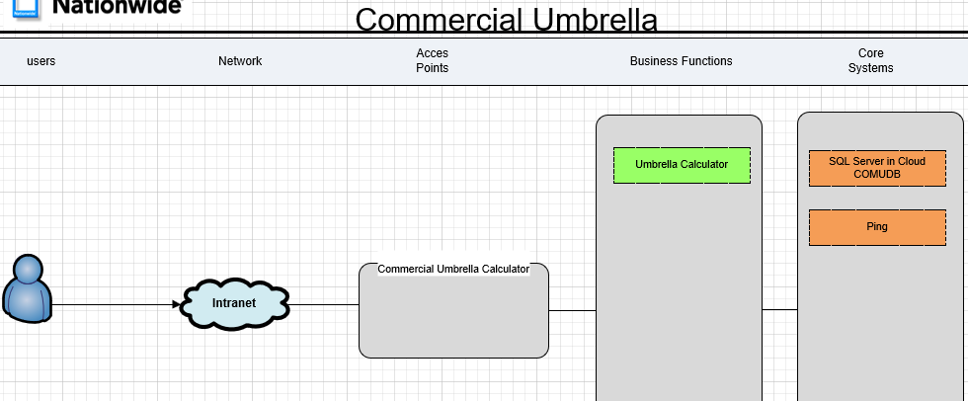

Stakeholders
Stakeholder Name | Organization | Role | Contact Information
Colleen Esposito | CLS BSA | SEPM
Scott Grau | CLS BSA | Architect
Bill Mardis | CLS BSA | Technical Lead
Angie Pike | CLESS | Business Delivery Executive
Others????

Integrations / System Context Diagram
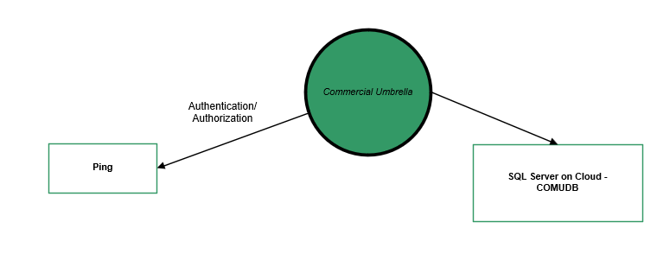

Integration Partner ID | Name | Consumer / Provider | Service Name | Type of Data Exchanged
 | Ping |  |  | Used for authentication/authorization
 | SQL Server |  |  | App reads and updates database COMUDB

Nationwide Process Integration
Nationwide Process ID | Process Name
 | ServiceNow
 | New Relic
 | IIQ
 | Vault
 | Archer

Technology Platform
Technology Type | Technology Name | Notes
Operating System
Application Server | AWS/Cloud
DBMS / File Type | SQL Server in Cloud | App reads and updates database COMUDB
Coding Language | Java
3rd Party S/W | N/A
Source Management System | Github | https://github.nwie.net/Nationwide/cis_commercial_umbrella

Sign Off

Reviewers
Name | Organization | Function / Role | Review Date
Angie Pike | CLESS | Business Delivery Executive | 4/17/26

Approvers
Name | Organization | Function / Role | Approval Date
Kirsten Charlton | MM | Executive Sponsor | 4/8/26
Marcello Presutti | MM Underwriting | AVP Underwriting | 4/10/26
Dawn Thompson for Rob Chenowith | SM Underwriting | AVP for VP Underwriting | 4/14/26
Tennielle Selby for Ann Sarosi | Farm | Sr Consultant for AVP | 4/9/26

Document History
Version | Date | Author | Summary of Changes | Document Location
1.0 | 4/8/2025 | Bill Mardis | Document started
2.0 | 1/27/2026 | Bill Mardis | Updated with details to get closer to being able to decommission the app

Appendix

